

Part 1 The installation and maintenance of XC-PLC edit tool
- System Requirement:
CPU: Pentium 133 or higher; Interior memory: Not lower than 16M; Disk space: Not less than 10M;
Operating system: Run under any version of Microsoft Windows, including Windows95/98, Windows ME, Windows NT, Windows2000, Windows XP etc.

- Installation:
Double click  Icon (Setup.exe) with your mouse, click “Next”--“Yes”—Input the serial number (ThingetXCP)—“Next”—“Next”—“Next”—“Next”—“Finish”. After this, please check your desktop, there will be a 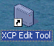 icon on your desktop!
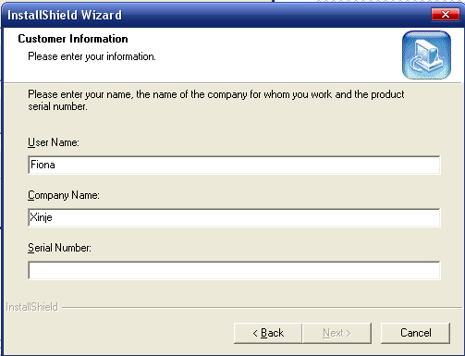

- Maintenance:
If you want to modify, repair or remove XCP edit tool, please choose Windows “Start—Setting—Control panel—Add/Delete XCP edit tool”, choose the item you want! (When you want to install a new version software, we suggest you remove the old version, not modify).

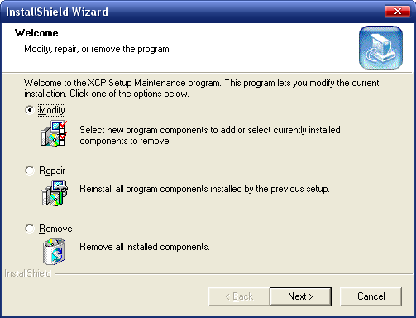

Part 2 Edit environment of XCP edit tool

- Edit environment:
The edit environment of XCP edit tool adopt the common edit environment, it has advantages of brief, high efficiency etc. The user could use it easily!
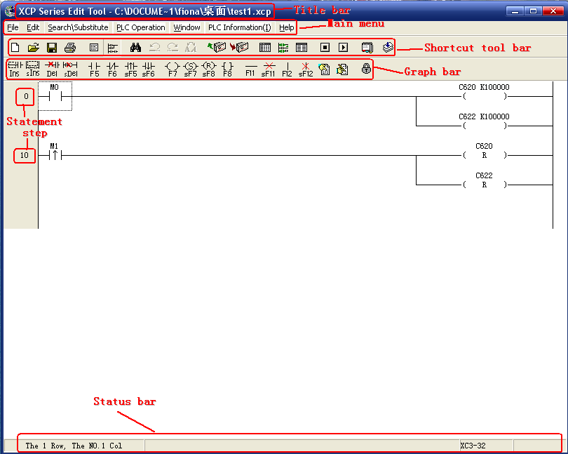

- Introduction of edit environment:
- Title Bar:
Show the current edit file name and its path
- Main Menu:
All the operation statements are placed by type in the five menus, via pull-down menu, you can choose the statement operation
- Shortcut Tool Bar
Offer 19 shortcut function keys to simplify the operation
- Graph Bar
Offer the tools required when compile the file
- Statement Step
Show the current statement step
- Status Bar
Show the current operation status

- Function keys
Function Keys | Usage
(New) | New Create a Ladder program
(Open) | Open an edited (saved) file
(Save) | Save the modified or new created file
(Printer) | Print the current file
(Display List) | Show the current program with statement
(Display Ladder) | Show the current program with ladder
(Search) | Search the statement or string
(Search Prev.) | Search the previous statement (be active in statement format)
(Search Next) | Search the next statement (be active in statement format)
(Search) | Replace the statement
(Upload) | Upload the PLC program to the computer
(Download) | Download the PLC program to the computer
(Data Monitor) | Monitor PLC register or coil
(Ladder Monitor) | Monitor PLC register or coil with Ladder format
(Free Monitor) | Monitor the data you are interested in
(Stop PLC) | Stop PLC
(Run PLC) | Run PLC
(Close/Open node comment) | Check the node comment
(Convert) | Convert to be the computer language (Not available at present)

- Graph Tools

Tool | Function | Shortcut Keys
 | Insert a Node | Insert
 | Insert a Rung | Shift + Insert
 | Delete a Node | Delete
 | Delete a Rung | Shift + Delete
 | Normally Open Node | F5
 | Normally Closed Node | F6
 | Rising Edge Pulse | Shift + F5
 | Falling Edge Pulse | Shift + F6
 | Out | F7
 | Set | Shift + F7
 | Reset | Shift + F8
 | Other Commands | F8
 | Horizontal Line | F11
 | Delete Horizontal Line | Shift + F11
 | Vertical Line | F12
 | Delete Vertical Line | Shift + F12
 | Ladder Comment
 | Node Comment
 | Lock Ladder Edit

Part 3: XCP edit tool Using

Edit Flow:
Run “XCP Edit Tool” on your desktop

New create or open XCP file

Compile the program with Ladder or statement

Connect PLC, download the program

Run PLC, monitor or debug

Modify the program till success, save the program

Part 4: Program Example of XCP Edit Tool

Summary:
Via compile a simple program, we will tell you how to use XCP edit tool in details!

Example Program:
- Record the active times of X0 with counter C0, when the count value reaches 10, output Y0, X1 is used as the reset signal of C0.
- Data register D21 automatically add 3 with the cycle of 2 seconds, use timer T0 as the time clock.

Ladder Program:

Statement program is more suitable for engineers who are familiar with PLC and logic program, while ladder program is chosen by operators who are starters. Here we use Ladder to realize our functions! Via XCP edit tool, simple program can be established by the edit tool which is similar with electric connection graph!

- Step 1:
Open XCP edit tool, choose the model you want (here we choose model XC3-32, the defaulted edit mode is Ladder)
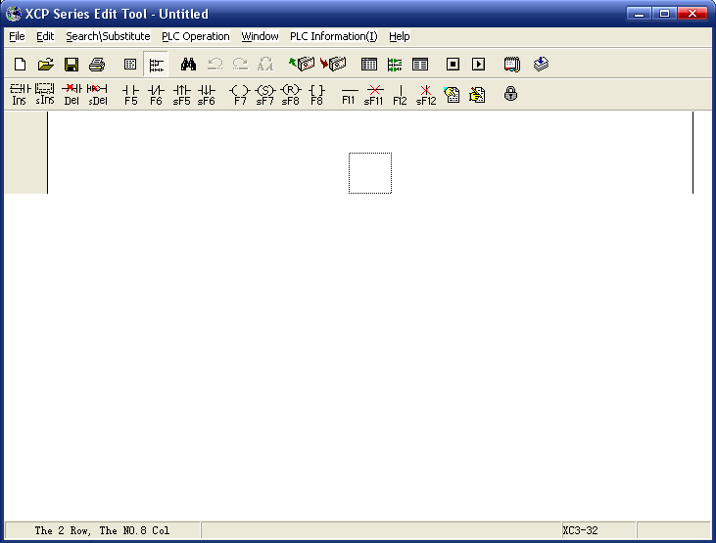

The dashed frame shows the current edit area.
First, click key (or press Shift + F5), the edit area displays in the inverse color (the defaulted input is M0), input X0. If input error, then this contact displays in red. Double click this contact, input this operand again.
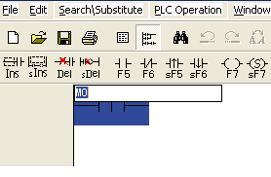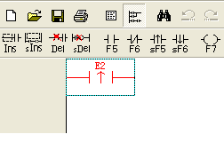
Waiting to input
Error input
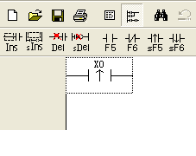
Correct input
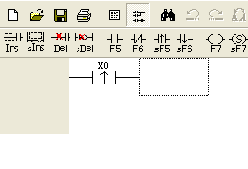
The edit tool shift right

Then the dashed frame right shift, keep on click icon (or click F11 key), the output contact will extend to the output terminal.
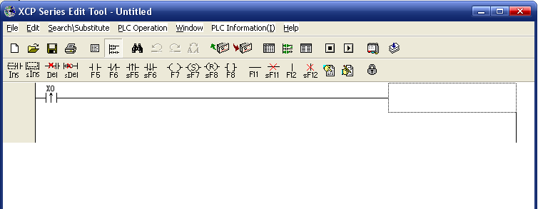

Or right shift the edit area, then click output key, the program will automatic connection.
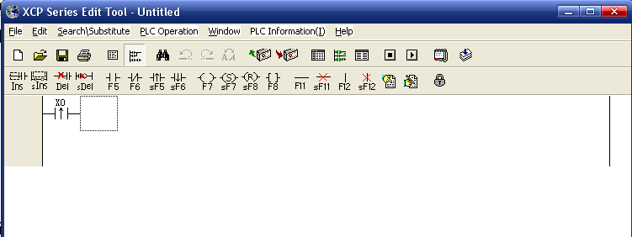

Click icon (or press F7)
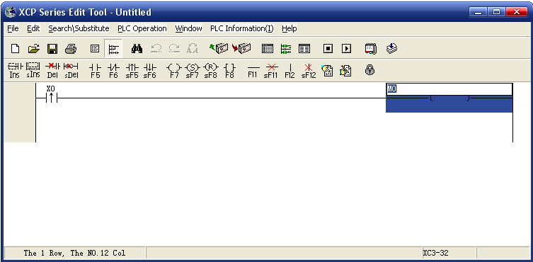

Input “C0 K10”.

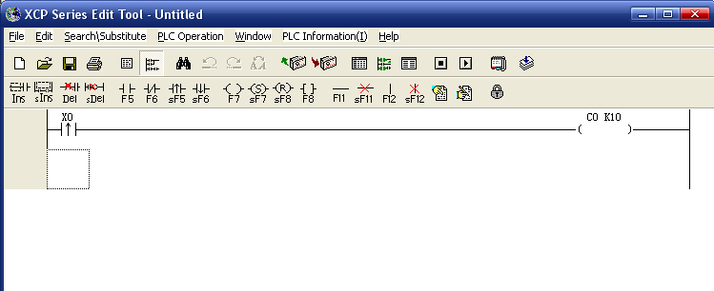

Input other statements:
Click (Or press F8)
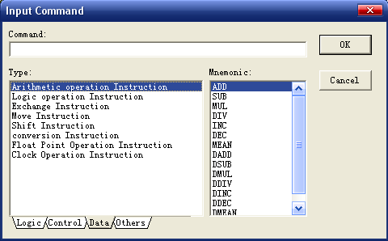

Choose the statement you need

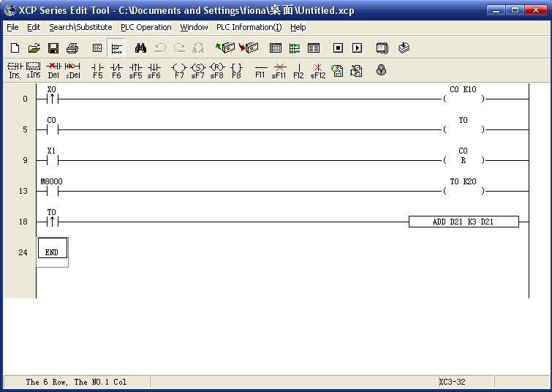

Check the program, download to the PLC after you confirm the correction.

Note:
The input format of statement is: “statement” + “space” + “operand”
If the contact is in red, it means the contact is wrong
Make sure the connection without any break lines

- Statement Program
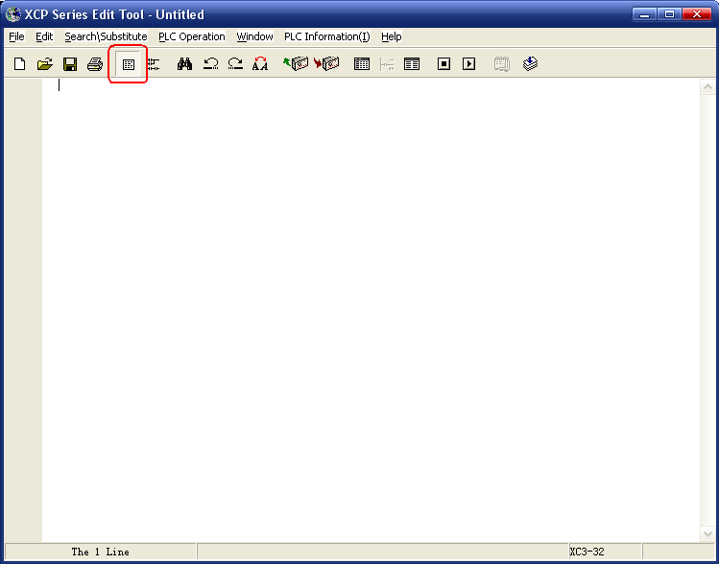
First, input statement “LDP X0”
When input the statement, there will be “?” in the left, it means the statement is not whole. At the same time in the status bar, there will be correspond clue.
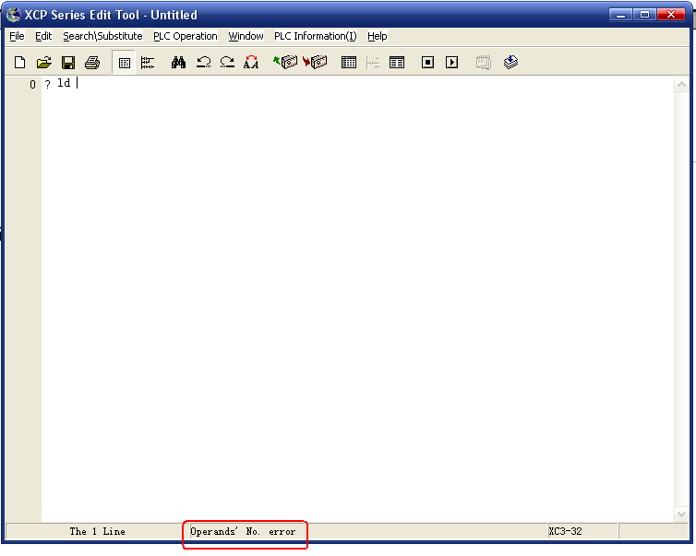

Input “LDP” + “space” + “X0”

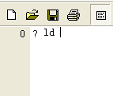
Short of operand
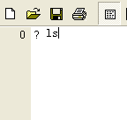
Statement error
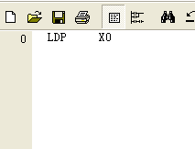
Statement correct
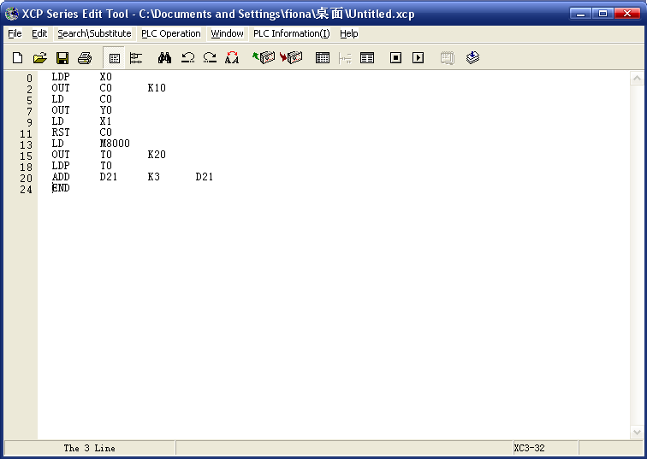

Click , convert to Ladder format.
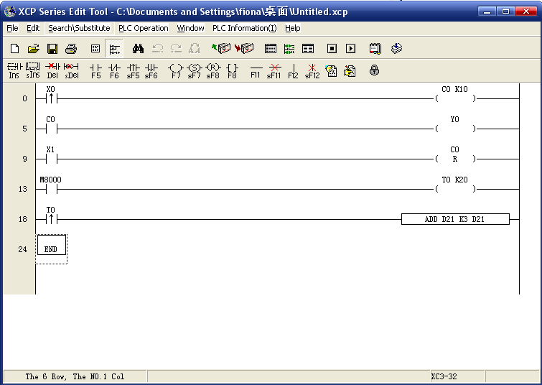

Check and make sure if the program is correct, download into the PLC.

Part 5: Downloading of the Program

Online Communication:

After confirm the correction of the program, connect the PLC and the computer with the cable, give PLC power. If your connection is correct, the gray icons in the edit tool will be active, it means the model is online, you could download the program and monitor.
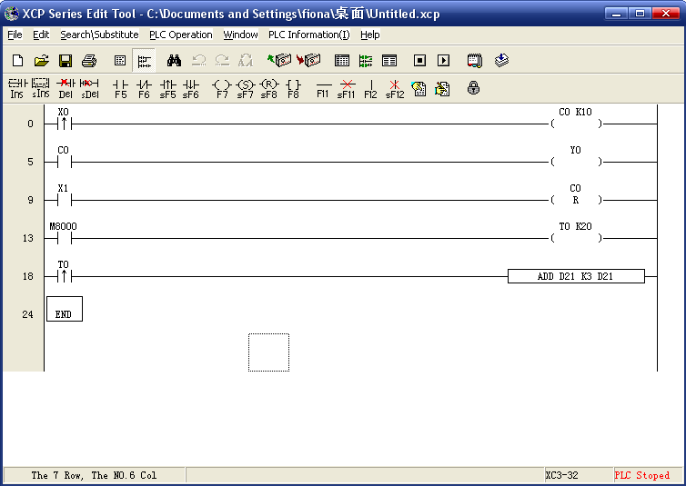

Download the Program:
Click key, download the program to the PLC. If PLC is running, there will come out a dialog ox shown below:
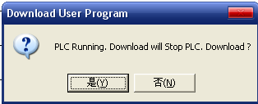

Choose “Yes”, PLC will stop running, download the new program.
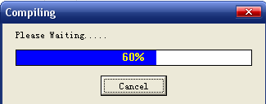
After finish downloading, click to run PLC.

Part 6: Monitor and debug of XCP program
Summary:
XCP edit tool offer online monitor function, you could check the program correct or not. There are three types of monitor: ladder monitor, data monitor and free monitor.

- Ladder Monitor:
- Ladder monitor is used to monitor the changing of coil and data register directly on the ladder.
- If coil’s color turns to be green, the line turns to be thick, it means active; If the color is still black, it means break
- Data register’s value, counter’s count value, timer’s time value are directly shown below the statement

Click icon, monitor the running status of program.
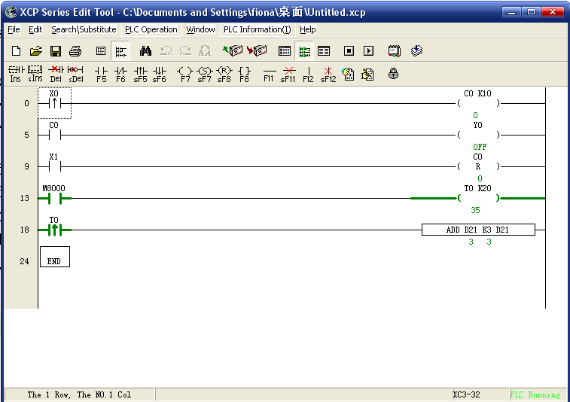

In the preceding graph, T0, M8000 are active, C0 is 0, Y0 is OFF.

- Data Monitor:
With data monitor, you can monitor coil’s status, data register’s value with table format. You can also modify register’s value or change coil’s status directly. As the monitor objects are centralized, data monitor fits the monitoring of large scale registers, coils etc.

Click icon, open data monitor table:

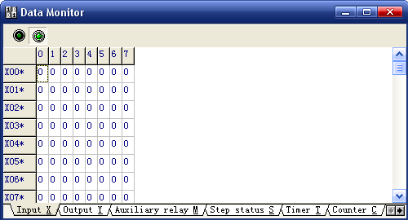

There are two buttons in the left top, you can start/stop monitor.
According to different type, you could choose “Input X”, “Output Y”, “Auxiliary relay M”, “Step status S”, “Timer Y”, “Count C”, “Interior register D”, “FlashROM register FD”, “Special coil M8000”, “Special register D8000”, “Special Flash register (FD8000)”, “Extension’s input register (ID)”, “Extemsion’s output register (QD)”.

Also in the window, we offer mode shift, including “Dec.”, “BCD/HEX”, “Unsigned” and “ASCII”.

Part 7: Encrypt of the program

You could input your password to protect your program. Please refer to the following steps:

- Set Password:
Step 1: 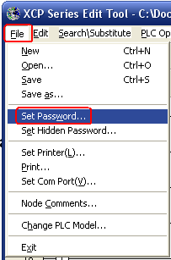
Step 2: 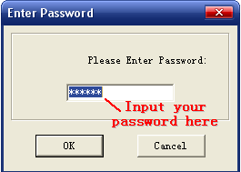

Then you will finish setting the password successfully!

After cut PLC power and give PLC power again, if you want to upload the program in PLC, you will be required to enter your password.
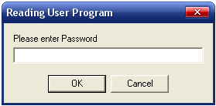
If you enter wrong password, you will fail to upload the program.
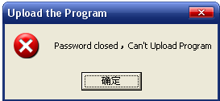

- Open/Cloce the Password:
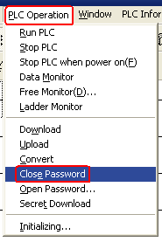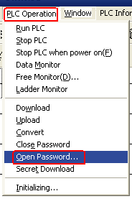

Note:
After PLC set the password, only when cut the power and then give it power again, the password will be effective. Then if you want to read PLC program, you should open the password first! When download PLC program, password is not necessary. If your password is lost, download the program again!

Scantech Automação Industrial Ltda
R. Luigi Francesco Hungaro 97 Cj 03
Jd. São Camilo – Boituva – SP
CEP 18.550-000
Tel (15) 3363-6001
email: atendimento@scantech.ind.br
website: www.scantech.ind.br



